

NCIA – National Cancer Imaging Archive

Software Design Description

Release 1.2 – Annotations

NCIA Team:

Jon Dietrich

James Luo

Andrew Shinohara

Jin Chen

Derek Kong



Document Change Record
Version Number | Date | Description
1.0 | 01/13/06 | Initial document
1.1 | 01/19/06 | Updated after reviews

TABLE OF CONTENTS
1. Introduction 1
1.1 PROJECT BACKGROUND 1
1.2 SYSTEM OVERVIEW 1
1.3 Requirements Traceability 2
1.3.1 Relevant Statement of Work Tasks 2
1.3.2 Functional and Technical Requirements 2
2. Use Cases 4
2.1.1 New Use Cases 4
2.1.2 Changes to Existing Use Cases 6
3. System Architecture 14
3.1 UPGRADE MIRC SOFTWARE 14
3.2 Deploy MIRC on jBoss 14
4. configuration 15
4.1 Field Center 15
4.2 NCIA MIRC 15
4.2.1 Store to Annotations to File System 15
5. Components 16
5.1 MIRC Database adapter 16
5.1.1 DICOM Files 16
5.1.2 XML and ZIP Files 16
5.1.3 Domain classes 17
5.2 USER INTERFACE 18
5.2.1 Search Page 18
5.2.2 Search Results (Studies for Subject) Page 19
5.2.3 Search Results (Images for Series) Page 20
5.2.4 Data Basket Page 20
5.3 User interface Backing Beans 21
5.3.1 SearchWorkflowBean 21
5.3.2 SeriesDTO 22
5.3.3 BasketSeriesItemBean 22
5.4 MIDDLE TIER 22
5.4.1 AnnotationsCriteria 22
5.4.2 DICOMPatientQueryHandler 23
5.4.3 StudyResultSet 23
5.4.4 ResultSetManager 23
5.4.5 DataBasketQueryHandler 23
5.4.6 DataBasketSeriesResultSet 24
5.4.7 DataBasketAnnotationResultSet 24
5.4.8 DataBasketAnnotationListResultSet 24
5.4.9 DataBasketAnnotationsQuery 24
5.4.10 DataBasketResultSetManager 25
5.4.11 QueryHandlerProxy 25
5.4.12 DataBasketAnnotationsQueryHandler 25
5.5 UTILITIES 25
5.5.1 Zip Manager 25
5.6 BACK END 26
5.6.1 Domain Classes 26
5.6.2 Database Design 27
5.6.3 Views 28
5.6.4 Indexes 28

Introduction
The purpose of this document is to describe the design for the Annotations feature being developed for Release 1.2 of the NCIA – National Cancer Imaging Archive software.
The enhancement will provide new functionality to allow annotations to be submitted to the archive and allow users to search for series that have annotations. Annotations consist of data that is related to a series of images. The most common example of an annotation is image markup. Image markup is lines and text that a radiologist draws on an image to point out certain features such as a tumor. Other examples of annotations are pathology reports, radiologist reports, etc. There is no standard for storing annotations.
For Release 1.2, the only type of annotation supported will be XML files and zip files containing image markup.

PROJECT BACKGROUND
Please refer to the NCIA Architecture Overview for background on the NCIA project.

SYSTEM OVERVIEW
Please refer to the NCIA Architecture Overview for a system overview.
.

Requirements Traceability

Relevant Statement of Work Tasks
The NCIA Statement of Work (SOW) Task Description contains the following items that will be implemented as part of this design:
4. Implement initial submission and download of image markups from designated investigator sites

a. Implement integrated I3 solution that supports the de-identification and association of images to image markup files at series level. The image annotation / metadata with in the image markup files will be stored the I3 repository. This release will not support Files that are just bundled where NCI needs to create a system to link them
b. Support submission to NCI of xml files containing image markup from designated investigator sites (e.g. LIDC, IDRI)
c. Perform a detailed use case analysis of image markup annotations for designated investigator sites (e.g. LIDC, IDRI)
d. Enhance database to flag the image series to indicate if markup data is available
e. Support MIRC server files system for image markup data. Upgrade MIRC to version T27 when it is available. FieldCenter software of MIRC version T27 (developed by John Perry) keeps the original association between image markup and image series and passes it to I3.
f. Link image markup to image series in I3 database by parsing one XML field (series instance UID) into database. All the submitted markup XML files need to following this guideline
g. Implement data basket and download to support download of the images and associated markup data if available
h. Implement, test, and deploy the above described requirements.

Functional and Technical Requirements

The following is a more detailed list of requirements for this enhancement:
ID | Requirement
1 | Allow field centers to submit image markup data as XML and ZIP files to NCIA’s MIRC. Image markup data in XML and ZIP format is the only type of annotations that will be supported for Release 1.2.
2 | Link annotations to their related series by extracting the series instance UID.
3 | Provide the ability for users to search for series that contain annotations. Data within the annotation files will not be available for search in Release 1.2.
4 | In the search results and data basket, display to the user whether or not a series has annotations.
5 | Include annotation files in zip files to be downloaded.
6 | Patient identifying data must be removed from annotation files and the annotation file name prior to being stored in NCIA.
7 | Provide flexibility to support many different XML schemas in the future.

Use Cases
User preferences requirements were documented by a combination of adding new use cases and updating existing use cases.

New Use Cases

Receive Annotation File Use Case

Use Case Name | Receive Annotation File
Use Case ID | 1.2
Primary Actor | Field Center, NCI MIRC
Trigger | Annotation file is received at the NCI MIRC. MIRC Field Center software was used to submit the Annotation file to the NCI MIRC.
Pre-conditions | 1. MIRC Field Center software has removed any patient information from the Annotation file (this is configurable in MIRC).  2. MIRC Field Center has removed any patient information from the filename of the Annotation file (this is configurable in MIRC).  3. The MIRC Field Center software has been installed and configured correctly.  4. The NCI MIRC has been installed and configured correctly.  5. The versions of MIRC and Field Center that are installed are the versions that support submission of annotations.  6. The annotation file is either an XML file or a ZIP file.
Flow of Events | - NCI MIRC receives the Annotation file.  - The Study Instance Unique Identifier (UID) is extracted from the Annotation file. For XML files, it is extracted from the annotation file itself. For ZIP files, it is extracted from manifest.xml within the zip file.  - The Series Instance UID is extracted from the Annotation file.  - The annotation file is stored in the file system in the same directory that series are stored in for the study with the Study Instance UID extracted from the file. The name of the file is the same as its Series Instance UID.  - A record is created in the database that stores the path to the annotation file and the Series Instance UID. No other data is stored in the database from the annotation file.  - If a series with the Series Instance UID already exists, the annotation flag for the series is updated to true and the annotation record is updated to point to the series.
Post-Conditions | Success Condition: The Annotations file is stored in the file system. The corresponding series has been updated in the database.  Error Condition: If the Annotations file is submitted electronically, the transmission could be disrupted midway and the file can fail to reach the destination.
Alternative Flow | - A series with the Series Instance UID does not exist yet. When the series is created, the annotation flag will be set to true and the annotation records will be updated to point to the series.  - The Annotations file can be sent via a removable medium (like DVD, Hard Drive). In this case, the file is submitted via the NCI Field Center software (return to Step 1 above).  - If the Annotations file is submitted electronically, the transmission could be disrupted midway and the file can fail to reach the destination.  - The administrator at the field center site resends the files to NCI MIRC.  - If the Annotations file is submitted via a DVD at a local field center, the administrator resends the file to NCI MIRC.  - If the Annotations file is resent from the field center, the NCI MIRC software will update the MIRC document and the database if the record has already been updated.  - The Annotations file cannot be stored in the MIRC queue due to maximum capacity reached.  - Administrator can request for more hard drive space.  - The administrator at the field center site resends the files to NCI MIRC.  - If the Annotations file is submitted via a DVD at a local field center, the administrator at the local field center can resend the file to NCI MIRC.  - NCI MIRC software will update the MIRC document and the database.
Related Use Case

Changes to Existing Use Cases
The changes relevant to this enhancement are highlighted in yellow.

Parse and Store DICOM File Use Case

Use Case Name | Parse and Store DICOM File
Use Case ID | 1.3
Primary Actor | NCI MIRC
Trigger | See use case 1.1.
Pre-conditions | - DICOM image has been received by the NCI MIRC.  - Annotations associated with the DICOM file and the DICOM file were sent and anonymized by the same field center.
Flow of Events | - The DICOM parser reads the DICOM file  - The parser parses the header information based on a property file set by the administrator.  - Data provenance information is extracted from the DICOM header.  - The parser stores selected DICOM header information and the data provenance information in the database. If the subject, study, or series for this image does not exist yet, it will be created.  - If this image is the first image for its series, check to determine if there are any annotations for the series. If there are, set the annotation flag for the series to true and set the annotation records to point to the series.  - The location of the image is stored in the database.  - Visibility for the image is set to false in the database.  - The DICOM file is anonymized to remove data as specified by the curation process (e.g. data provenance information).  - The anonymized DICOM file is saved to the file system. The directory structure used contains subdirectories for the trial, subject, study, and series.
Post-Conditions | Success Condition: Image is stored in file system. Data for the image is stored in database.  Error Condition: The DICOM parser fails to parse the DICOM file
Alternative Flow | - The DICOM parser fails to parse the DICOM image  - The DICOM file is stored to a quarantine folder for later processing and submission  - The administrator at the field center site resends the files to NCI MIRC  - If the DICOM file is submitted via a DVD at a local field center, the administrator at the local field center can resend the file to NCI MIRC  - NCI MIRC software will update the MIRC document and the database
Related Use Case | 1.1 Receive DICOM File

Perform Simple/Advanced Search Use Case

Use Case Name | Perform Simple/Advanced Search Use Case
Use Case ID | 9.1
Primary Actor | Researcher
Trigger | Researcher has logged into the system and has clicked on the Simple or Advanced Search links from the main page
Pre-conditions
Flow of Events | - Researcher clicks on the Simple or Advanced Search link from the main page  - Researcher is presented with a list of DICOM search fields to fill out. The following DICOM fields will be presented to the user  - Simple Search - image modality, contrast, anatomic site, image slice thickness, presence of annotations, and collection. The Collection field is filtered based on use case 9.7 (Filter Collection List on Search Page Based on CSM Authorization).  - Advanced Search – image modality, contrast, anatomical site, image slice thickness, minimum number of studies, number of months between baseline and final study, collection, manufacturer, model, equipment software version, series description, , Convolution Kernel Type, Kilo Voltage Peak Distribution,  - Researcher enters the fields to be searched and the condition for search (if any)  - Researcher clicks on the submit button  - The system then  - validates the data entered and  - Calls use case 9.6 (Filter Data in Results Based on CSM Authorization).  - if no exceptions occur, displays the search results  - saves the query, the elapsed time to run the query and a timestamp of was run in the user’s query history
Post-Conditions | Success Condition: Researcher is presented with the search results screen to view the results (see use case 10.1).  Error Condition: Invalid Data or Incomplete Data.  Error Condition: System error while processing the search query
Alternative Flow | - If a validation error is thrown, the system displays the appropriate error and redisplays the page.  The actor can then  - add additional data, edit entered data or clear the screen and re-enter all selection (return to step 3 above)  - Logout of the system and terminate the process  - If system error is thrown, the researcher is asked to contact the system administrator to report the type of error thrown
Related Use Case

Display Search Results Use Case

Use Case Name | Display Search Results Use Case
Use Case ID | 10.1
Primary Actor | Researcher (via Simple/Advanced Search)
Secondary Actor | Image data store  Annotation Database
Trigger | System has successfully retrieved the user requested data for display
Pre-conditions | - The query is executed without any system errors
Flow of Events | - The system has successfully retrieved the data requested by the user.  - The search results page includes a list of subjects sorted by Subject ID that have at least one visible image matching the criteria. For each subject, the results include:  - Subject ID  - Trial ID  - The number of studies and series for the patient that contain at least one visible image meeting the criteria  - The total number of studies and series for the patient  - A “Show Studies” link.  - The actor can click on the Show Studies link to “drill down” to the study level.  - The Search Results (Studies for Subject) page is displayed. It includes a list of all of the studies or the selected subject (sorted by study date) that contain at least one visible image matching the criteria. For each study, the following is displayed:  - Study ID  - Study Description  - Study Date  For each study, a list of series (ordered by series number) for the study that have at least one visible image matching the criteria is displayed. For each series, the following is displayed:  - Series ID  - Total Number of Images in the Series  - Note: This number includes both visible images that meet the criteria and those that don’t.  - Series Description  - Series Modality  - Series Equipment Manufacturer  - Whether or not an annotations file exists for the series  - A “Show Images” Link  - The user clicks the “Show images” link to display the visible images in that series. (See use case 10.2).  - The system displays a set of thumbnails for all the visible images in the series sorted by the image date. (Thumbnails for visible images that do not match the criteria are displayed also).
Post-Conditions | Success Condition: User views the results.
Alternative Flow | - If no data is returned by executing the query, an appropriate message is returned to the search results page  - On the subjects page, user clicks on the icon in a column title to sort the list by the data in that column.
Related Use Case | Search Annotation  10.2 Display Image Thumbnail  10.3 Display Annotation  11.1 Export Images

Manage Data Basket Use Case

Use Case Name | Manage Data Basket Use Case
Use Case ID | 11.5
Primary Actor | Researcher (via Simple/Advanced Search)
Trigger | - User clicks on the “Manage Data Basket” link to manage the data basket.
Pre-conditions | - The user has added images and set of images of interest to the data basket and is ready to download the images.
Flow of Events | - User clicks on the “Manage Data Basket” link  - The user is presented with a list of the series that are currently in the data basket. For each series, the following data is displayed:  - Subject ID  - Study ID  - Series ID  - Number of Images Selected out of Number Available  - Whether or not the Series has annotations  - Size of all DICOM file and annotation files (in MB)  - If desired, user can remove images from the data basket.  - The user is shown the approximate total size of the download and the approximate time it will take for the download  - When they are ready, they can click on the “Download” button to begin the download process  - If total size is below the HTTP download threshold, a progress bar is displayed to show the progress of the file being zipped. Control is passed to use case 11.6 (Compress Images). As the file is zipped, the progress bar is updated.  - If the size is above the HTTP download threshold, a message is displayed indicating to the user that they should expect an email with a link to download the file via FTP. System executes use case 11.6 (Compress Images) in the background while the user is able to continue using the application.  - The user has the option to cancel the download process.
Post-Conditions | Success Condition: The download is successful without any errors  Error Condition: The system throws an exception during the download process  Error Condition: The system throws an exception while removing data from the data basket
Alternative Flow | - If the user chooses to remove an image or set of images from the data basket, the system will remove them and then displays the Manage Data Basket screen  - If a system exception is thrown, an appropriate system error is returned to the user. The user can contact the administrator with the error message
Related Use Case | 11.6 Compress Images

Compress Images Use Case

Use Case Name | Compress Images Use Case
Use Case ID | 11.6
Primary Actor | Researcher (via Simple/Advanced Search)
Trigger
Pre-conditions | - The user has added all the images and set of images of interest to the data basket and has clicked on the “Download” button
Flow of Events | - The system copies the images and annotation files from the file system location to a temporary location as specified by a system properties file  - If the series for an image contains annotation files, copy the annotation files to the temporary location.  - The system then compresses all the images and annotation files using the zip format.  - If downloading via FTP or DVD, the user is sent an email indicating that the file is now ready for them.  - If downloading via HTTP, control is then passed over to the Download Selection using HTTP Use Case (UC # 11.10)
Post-Conditions | Success Condition: The images have been successfully zipped and are ready to be downloaded. A record has been added to the download history table. The table contains the date/time when the zipping was completed, the size of the data that was zipped (not the size of the file), the amount of time it took to zip the file and a reference to the user that requested the download.  Error Condition: The system throws an exception during the copying or zipping process
Alternative Flow | - If a system exception is thrown, an appropriate system error is returned to the user. The user can contact the administrator with the error message
Related Use Case | 11.5 Manage Data Basket  11.7 Download selection

System Architecture

UPGRADE MIRC SOFTWARE
For this enhancement, the MIRC software will be upgraded to version T27. The version of MIRC used in Release 1.1 only supports submission of DICOM files. The new version supports the submission of annotation files in either XML or zip format. Zip files are supported to allow for submission of multiple files for a series simultaneously. T27 also supports preprocessing of annotation files to allow for anonymization.

Deploy MIRC on jBoss
Version T27 also supports running on jBoss. In current production, MIRC runs as a web application (WAR) on a Tomcat instance that is separate from the jBoss instance that NCIA runs on. For release 1.2, MIRC will be deployed in jBoss as a separate WAR from NCIA.

configuration

Field Center
Field centers use MIRC Field Center and File Sender software to submit files to NCIA’s MIRC. Field Center and File Sender can be configured to preprocess DICOM files prior to submitting the files. In Release 1.1, field centers use the preprocessing functionality to anonymize data in the DICOM fields.
For Release 1.2, the field centers will leverage new functionality included in the new version or MIRC that provides for preprocessing of XML files before they are submitted. Field centers will be configured to anonymize the image ID, study instanceUID and series instance UID. Configuration files allow for the specification of the fields to change (specified as XPATH) and how to change them. The anonymization algorithm will be the same used to anonymize those fields in the DICOM file. Using the same algorithm allows the annotation XML and the series to be linked together.

NCIA MIRC

Store Annotations to File System
Version T27 of MIRC supports submission of well-formed XML and zip files. The series and study instance UIDs must be extracted from the files. For an XML file, the UIDs are contained within the XML file. For zip files, the UIDs are contained in a well formed manifest.xml file that is contained inside of the zip file. For either type of file, the XML schema does not matter. MIRC searches the files for a tag or attribute with a certain name (see below).
Upon receiving an XML or zip file, MIRC does the following:
- Extracts the study instance UID from the XML file. It does this by looking through the XML tags to find an attribute or tag named “study-uid” or “StudyInstanceUID”. For a zip file, it extracts the values in a similar fashion from a file named manifest.xml that is contained within the zip file.
- Store the file in the file system in the study’s directory. The file name will be the same as the series instance UID (extracted by MIRC by looking for an attribute or tag called “series-uid” or “SeriesInstanceUID”.
- Calls the DatabaseAdapter to allow for exporting to a database. The DatabaseAdapter to call is set in a configuration file.
The algorithm for determining the study instance UID allows different trials to place the study instance UID in different locations in the XML as long as the same tag or attribute name is used. If “study-uid” or “StudyInstanceUID” is not used, the pre-process functionality can be used at the field center to copy the UID to those fields.

Sequence diagrams
For some use cases, sequence diagrams are helpful to illustrate the execution flow. Sequence diagrams are included this section for the appropriate use cases. Details of the objects that participate in the use cases are described in section Error: Reference source not found.

Receive Annotation File
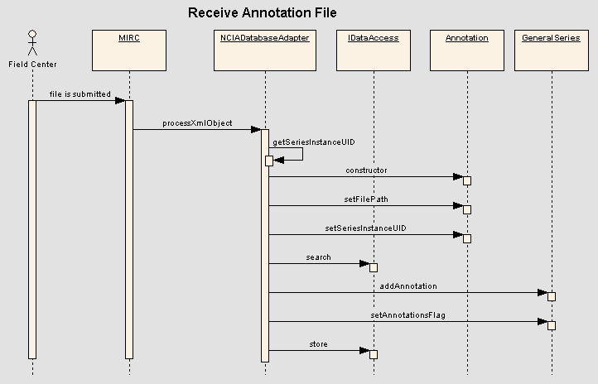

Parse and Store DICOM File
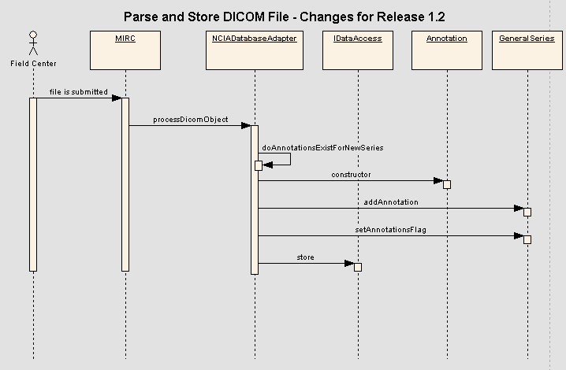

Perform Simple/Advanced Search Use Case
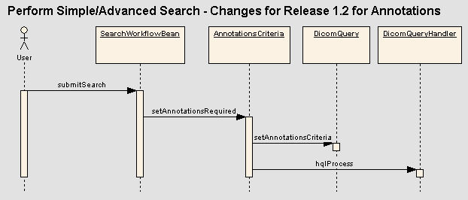

Compress Images Use Case
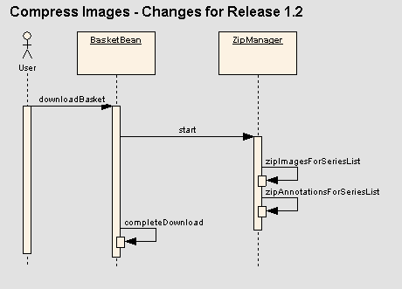

Components

MIRC Database adapter
MIRC provides hooks for applications to specify how data from submitted files will be placed in the database. Prior to Version T27, adding database export functionality required modifying MIRC code. Version T27 allows applications to extend the DatabaseAdapter class. The application’s DatabaseAdapter (based on a configuration file) will then be called as part of the submission process.

DICOM Files
For Release 1.1, MIRC’s DatabaseExportService was modified to export data to the NCIA database. For Release 1.2, the custom NCIA code in DatabaseExportService will be moved to NCIADatabaseAdapter (extends MIRC’s DatabaseAdapter class) to take advantage of the new, cleaner approach to database exporting that is provided in the new version of MIRC.
In addition to moving the logic to NCIADatabaseAdapter, a new process will be included to update the Annotations objects related to a series. This process ensures that annotations submitted prior the first image for the related series will be linked to the series once the first image is submitted for the series. In Release 1.1, when the first image is submitted for a series, a GeneralSeries object is created and saved.
For Release 1.2, an extra step needs to occur to check if there are any Annotation objects that meet both of the following criteria:
- Annotation.GeneralSeries is null, meaning that the annotation was submitted prior to its related series
- Annotation.SeriesInstanceUID equals the series’s instance UID.
If any Annotation objects are found, make the following updates:
- Set the GeneralSeries.AnnotationsFlag = True
- Add the Annotation objects to be children of GeneralSeries.

XML and ZIP Files
The processXmlObject() and processZipFile() methods of NCIADatabaseAdapter will be implemented to export data from XML files when they are submitted to NCIA’s MIRC. The process will be as follows:
- Extract the Series Instance UID from the XML. This will be done in using the same algorithm that MIRC uses to extract the Study Instance UID. The system will look for attributes or tag with the names “series-uid” or “SeriesInstanceUID”. If a series instance UID cannot be extracted, the file will be quarantined. For zip files, the UIDs are found in a file named manifest.xml contained within the zip.
- Create an Annotation domain object to represent the annotation. Set the following attributes:
- Path to annotation file
- Series Instance UID
- Annotation type
- Attempt to load a GeneralSeries object from the database with the Series Instance UID extracted in step 1.
- If no GeneralSeries object is found (meaning that the annotation is being submitted before any images for the series), save the Annotation object.
- If a GeneralSeries object is found (meaning that images for the series have been submitted prior to the submission of the annotation), do the following:
- Set the Annotations attribute of the GeneralSeries object to True
- Add the Annotation object as a child of GeneralSeries. Set the GeneralSeries attribute of the Annotation object to point to the GeneralSeries.
- Save the GeneralSeries object. This also saves the child Annotation.

Persistence is handled through the use of Hibernate domain objects. The appropriate domain classes and mapping files are deployed with MIRC.
The algorithm for determining the series instance UID allows different trials to place the study instance UID in different locations in the XML as long as the same tag or attribute name is used. If “series-uid” or “SeriesInstanceUID” is not used, the pre-process functionality can be used at the field center to copy the UID to those fields.

Domain classes
Changes to domain classes are described in section 6.6.1. These domain classes and their mapping files must be added to the MIRC deployment to allow for access to those objects in the database.

USER INTERFACE

Search Page
The Search page will be changed to include a new criterion. The new criterion will display on both the Simple and Advanced Search pages below the Collections criterion. The checkbox will be linked to SearchWorkflowBean.AnnotationsFlag. It will appear as follows:

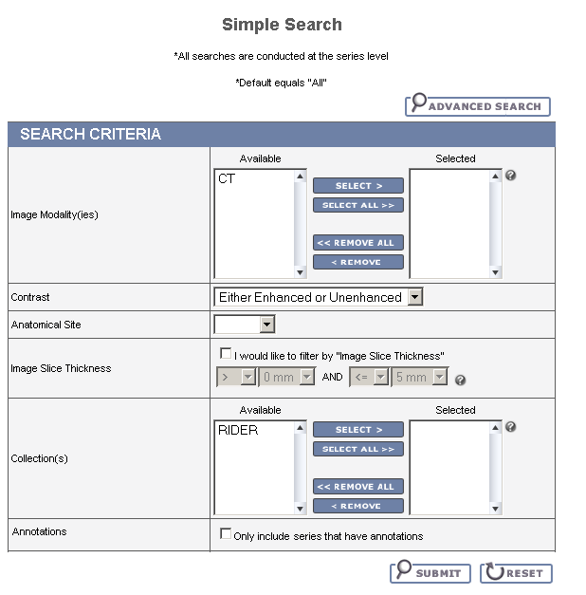

Search Results (Studies for Subject) Page
The Search Results (Studies for Subject) will be changed to include whether or not each series has annotations. If SeriesDTO.AnnotationsFlag =True, display “Yes”. Otherwise, display “No”. It will appear as follows:

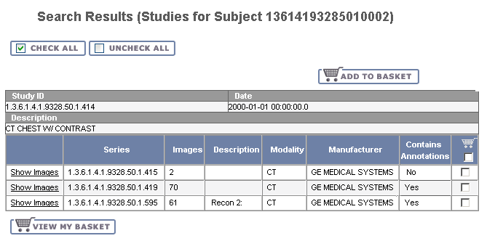

Search Results (Images for Series) Page
The Search Results (Images for Series) will be changed to include whether or not the series has annotations. If SeriesDTO.AnnotationsFlag =True, display “Yes”. Otherwise, display “No”. It will appear as follows:

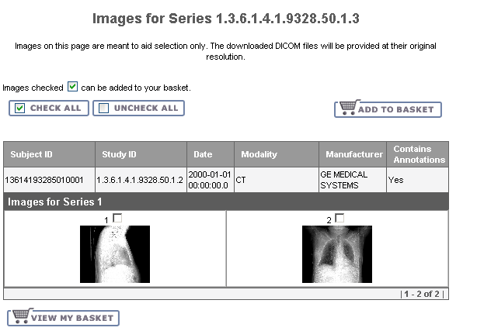

Data Basket Page
The Data Basket Page will be changed to include a new column that indicates whether or not each series has annotations. If BasketSeriesItemBean.AnnotationsFlag =True, display “Yes”. Otherwise, display “No”. It will appear as follows:

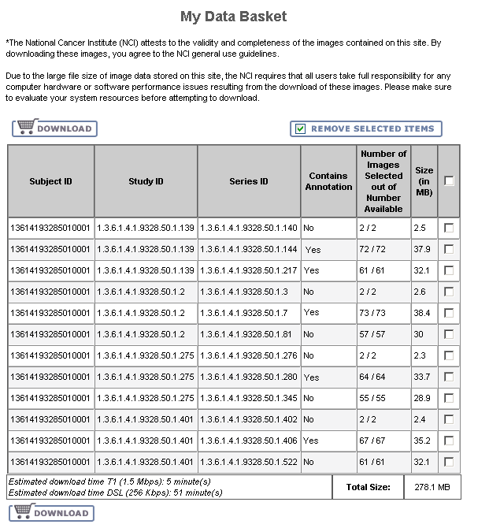

User interface Backing Beans

SearchWorkflowBean
SearchWorkflowBean manages the search process. When a user submits a query, it stores the submitted criteria and creates a DicomQuery based on it. To store the new AnnotationsCriteria, a new attribute must be added as follows:
New Attribute | Type | Description
AnnotationsFlag | Boolean | Indicates the user has checked the “Only include series with annotations” checkbox

The submitSearch() method must be changed to add an AnnotationsCriteria object to DicomQuery if the user checked the annotations checkbox. If the checkbox is not checked, no AnnotationsCriteria will be added.

SeriesDTO
SeriesDTO is an existing class used to hold data in memory for a series. The following new attribute will be added:
New Attribute | Type | Description
AnnotationsFlag | Boolean | Set to true if this series has annotations. False otherwise.

BasketSeriesItemBean
BasketSeriesItemBean represents a series (or some images from a series) that has been added to the data basket. The following new attribute will be added:
New Attribute | Type | Description
AnnotationsFlag | Boolean | Set to true if this series has annotations. False otherwise.
AnnotationsSize | Long | Total size of all annotations for the series

The following method will change:
Method Name | Description
getSize | Change to return the size of all the Dicom images plus the size of all annotations.

MIDDLE TIER

AnnotationsCriteria
A new criteria class named AnnotationsCriteria will be added. It will have the following methods:
New Method Name | Description
setAnnotationsRequired | If set to true, indicates that the user only wants to return series that include annotations. If false, the user wants series with or without annotations.
getAnnotationsRequired | Returns true if the user only wants images with annotations, false otherwise.

DICOMPatientQueryHandler
DICOMPatientQueryHandler creates HQL based on a patient primary key passed in. After building the HQL, it calls the back end to execute a query and place the results into a StudyListResultSet object, which is a list of StudyResultSets.
The class will be modified as follows:
- Include series.annotations in the HQL to return the value of the annotations flag for each series
- Populate each StudyResultSet with the annotations flag based on the results returned.

StudyResultSet
The StudyResultSet class represents one row of data returned from the query executed by DICOMPatientQueryHandler. The following new methods will be added:
New Method Name | Description
setAnnotationsFlag | Setter for the annotations flag. Setting this to true indicates that the series represented by the PatientResultSet has annotations
getAnnotationsFlag | Returns the value of the annotations flag.

ResultSetManager
ResultSetManager is responsible for the running a search based on a DicomQuery and managing the results. The following changes will be made to existing methods:
Method Name | Description of Change
getStudies | When creating each SeriesDTO, populate the ImageAnnotationsFlag based on the getAnnotationsFlag () method on StudyResultSet

DataBasketQueryHandler
DataBasketQueryHandler creates HQL to retrieve data basket information based on a patient or series ID passed in. After building the HQL, it calls the back end to execute the query and place the results into DataBasketSeriesResultSet objects.
The class will be modified as follows:
- Include series.annotations in the HQL to return the value of the annotations flag for each series
- Join the SeriesTotalAnnotationFileSize view to get the total size of all annotations for each series
- Populate each DataBasketSeriesResultSet with the annotations flag and annotations size based on the results returned.

DataBasketSeriesResultSet
The new DataBasketSeriesResultSet class represents one row of data returned from the query executed by DataBasketQueryHandler. The following new methods will be added:
New Method Name | Description
setImageAnnotationsFlag | Setter for the annotations flag. Setting this to true indicates that the series represented by the DataBasketSeriesResultSet has annotations.
getImageAnnotationsFlag | Returns the value of the annotations flag.
setAnnotationsSize | Setter for the total size of all annotations for the series
getAnnotationsSize | Returns the total size of all annotations for the series

DataBasketAnnotationResultSet
The new DataBasketAnnotationResultSet class represents one row of data returned from the query executed by DataBasketAnnotationsQueryHandler. Each object will contain:
- the primary key of the series
- the path to the annotation

DataBasketAnnotationListResultSet
The new DataBasketAnnotationListResultSet simply contains a list of DataBasketAnnotationResultSets. QueryHandlers can only return a single ResultSet class, so this class just encapsulates a list into one class.

DataBasketAnnotationsQuery
Add a new query class to support retrieving the paths to annotation files. The following methods will be included:
Method Name | Description
getSeriesIdCriteria | Setter for the series ID criteria
setSeriesIdCriteria | Getter for the series ID criteria

DataBasketResultSetManager
DataBasketResultSetManager will be changed to populate each BasketSeriesItemBean’s AnnotationsFlag with the annotations flag and annotations size values from DataBasketSeriesResultSet.
A new method will also be added to handle reading annotation file paths from the database:
New Method Name | Description
getAnnotationFiles | Create a SeriesIdCriteria based on the list of series IDs passed in. Add the criteria to a DataBasketAnnotationsQuery and run the query. Loop through the resulting DataBasketAnnotationResultSets to build a map that has the series ID as a key and a list of paths to annotation files as the data.

QueryHandlerProxy
QueryHandlerProxy determines which QueryHandler class to use based on the type of query passed in. Add code to ensure that for DataBasketAnnotationsQuery, DataBasketAnnotationsQueryHandler will be used.

DataBasketAnnotationsQueryHandler
A new QueryHandler class will be added to support retrieving paths to annotation files based on series IDs. It will build HQL to retrieve the file path. The list of series IDs from the query’s SeriesIdCriteria will be used to build the where clause. After running the query, place each result into a DataBasketAnnotationResultSet and then place all of the DataBasketAnnotationResultSets into a DataBasketAnnotationListResultSet.

UTILITIES

Zip Manager
ZipManager currently handles the process of zipping all images for series that have been added to the data basket. For Release 1.2, it will be changed to zip the annotations files for a series. Annotations files for a series will be placed in the same zipped directory as the images for the series.
The following changes will be made to ZipManager:
- The run() method currently calls zipImagesForSeriesList() for each “chunk” of series. The method will be changed to call zipAnnotationsForSeriesList() immediately following zipImagesForSeriesList() for each chunk of series. The same parameters that are passed to zipImagesForSeriesList() will be passed to zipAnnotationsForSeriesList().
- A new method named zipAnnotationsForSeriesList() will do the following:
  - Loop through the series IDs passed in. For each one, if the series’s AnnotationsFlag is true, add it to a list of series IDs that have annotations.
  - Call DataBasketResultSetManager.getAnnotationFiles(), passing in the list of series IDs that have annotations.
  - Loop through the resulting map. For each annotation file for each series, call the process() method on ZipFiles, passing in the required data to zip a file. This data includes the file path to the annotation file.

BACK END

Domain Classes

GeneralSeries
Description: Existing domain representing a series containing several images and annotations.
New Attributes:
New Attribute Name | Attribute Type | Description
AnnotationsFlag | Boolean | True if annotations exist for this series. This flag is updated by MIRC when series are submitted.
Annotations | One-to-many association to Annotation | List of annotations related to this series

Annotation
Description: Existing domain representing a series containing several images and annotations.
Attributes:
New Attribute Name | Attribute Type | Description
Id | Integer | Primary key (system generated)
FilePath | String | Path to the annotation file on the file system.
FileSize | Long | Size of the annotation file
Type | String | The type of file: “XML” or “ZIP”
SeriesInstanceUID | String | Series instance UID of the series that the annotation is related to. This must be stored to handle situations where the annotation is submitted to MIRC before the series exists in the database.
GeneralSeries | many-to-one association to GeneralSeries | Reference to the series that the annotation is related to. If the series has not yet been submitted to MIRC, this will be null, but SeriesInstanceUID will be populated.

SeriesTotalAnnotationFileSize
Description: Represents a view that contains the total size of all annotations for a series.
Attributes:
New Attribute Name | Attribute Type | Description
SeriesId | Integer | Primary key of series
FileSize | Long | Size of the annotation file

Database Design

GENERAL_SERIES
Table: GENERAL_SERIES
New column:
Column Name | Column Type | Class / Attribute Name
ANNOTATIONS_FLAG | VARCHAR2(5) | GeneralSeries.AnnotationsFlag

ANNOTATION
Table: ANNOTATION
Column Name | Column Type | Class / Attribute Name
ANNOTATIONS_PK_ID | NUMBER | Annotation.Id
FILE_PATH | VARCHAR2(300) | Annotation.FilePath
FILE_SIZE | NUMBER | Annotation.FileSize
ANNOTATION_TYPE | VARCHAR2(30) | Annotation.Type
SERIES_INSTANCE_UID | VARCHAR2(300) | Annotation.SeriesInstanceUID
GENERAL_SERIES_PK_ID | NUMBER | Annotation.Series

Views

SERIES_TOTAL_ANNOTATION_FILE_SIZE
View: SERIES_TOTAL_ANNOTATION_FILE_SIZE
DDL:
select a.general_series_pk_id, sum(a.file_size)
from general_series gs, annotation a
where a.general_series_pk_id = gs.general_series_pk_id
group by a.general_series_pk_id

Column Name | Column Type | Class / Attribute Name
SERIES_PK_ID | NUMBER | SeriesTotalAnnotationFileSize.SeriesId
TOTAL_FILE_SIZE | NUMBER | SeriesTotalAnnotationFileSize.FileSize

Indexes
To improve performance, an index will be added on the GENERAL_SERIES_PK_ID column of ANNOTATION. This index is needed because ANNOTATION will often be queried and joined using the GENERAL_SERIES_PK_ID column.

